MONTHLY TEST- FEBRUARY- 2020
Marks obtained:

Total:
30
Name: _____________
Grade: II Section___
Subject: Maths
Date:. 2 . 2020
Time: 1 Hour

I. Fill in the blanks: - (5x1=5)
1) 245 + 10 = _______
2) 312 + 100 = ______
3) 425 + 100 = ______
4) 542 - 10 = ______
5) 689 - 100= ______
II. Draw the following Problem:- (1x5=5)
6) A farmer had plucked 420 apples from his farm. He sold 320 apples to a shop nearby. How many apples is he left with?
Need to find out
What is given

Should you add or subtract + __
III. Fill the outline of the picture with zentangle patterns of your own.
(1x5=5)

IV. Create a question using the given numbers, location and character.
(1x5=5)
327, 200 Reena, Meena at the market

V. Circle the shape that comes next (6x1=6)
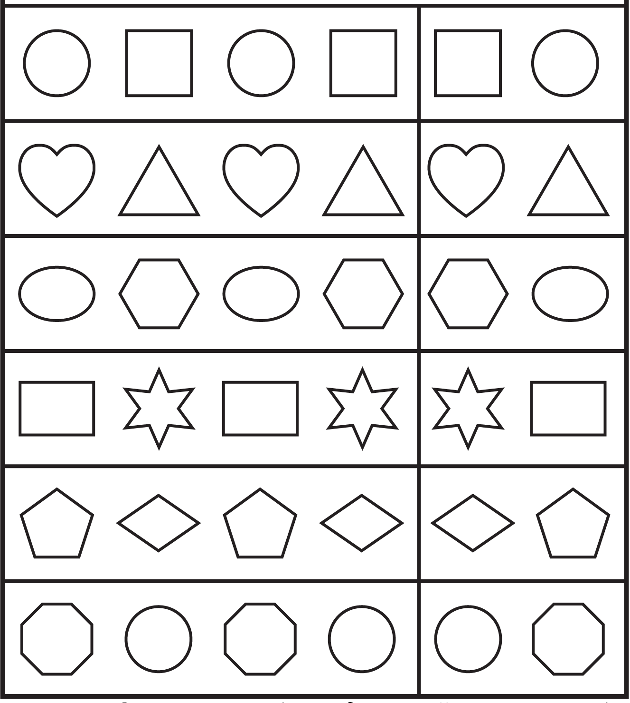

VI. Shade the pictures to create the same pattern as the ones on the left.
(4x1=4)
